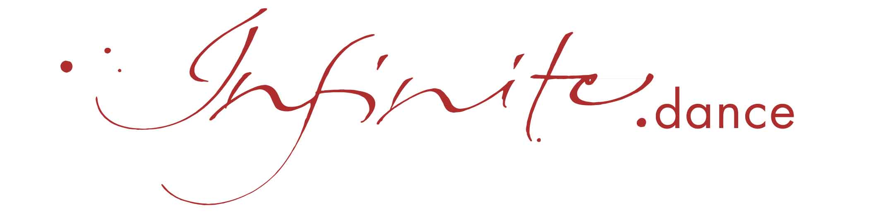
Registration Form

Seminar: Dance Oracle, part ………………………….

Place: …………………………………………………..

Date: from ........................... until …………………..

Seminar Fee: …….…… ,- Euros or

……….… ,- Euros with Early Bird discount

Name: …………………………………………………………………………….……

Street: ……………………………………………………………………………….…

Zip Code: ……………………………………………………………………………….…

Phone: ………………………………………………………………………………….

Email: ..…………………………………………………………………………………

____________________________________ __________________________________
Place & Date Signature

Important information
Please note, that accommodation, food and traveling costs are to be covered by the participants on top of the seminar fee. Please send the registration form completed and signed by e-mail to register@infinite.dance or by post to: Carola Stieber, Färberweg 5, D-79790 Küssaberg

Your registration is confirmed as soon as we receive from you the signed registration form together with the seminar fee on our account: IBAN: CH2208781000219415000, BIC: SWQBCHZZXXX, Swissquote Bank SA, account name and holder: Carola Stieber.
Please note in your transaction the title of the seminar, its location & date.

Cancelation: 50% of the seminar fee will be refunded, if you cancel until 31 days before the start of the seminar. Thereafter, the full seminar fee will be retained. On presentation of a medical certificate, the seminar fee minus a processing fee of 50 euros can be credited to a subsequent seminar within four years. Furthermore, it is possible to transfer the seminar participation - including the seminar fee minus 50 Euro processing fee - to someone else. In the event of cancellation by Infinite.dance, the entire seminar fee will be refunded to you.

This seminar is not a substitute for psychotherapeutic or psychiatric treatment. Each participant is responsible for his/her own health and wellbeing as well as liable for accidents or damages of any kind and has insurance for health, accidents and liability him/herself. For details visit our website.
.
www.infinite.dance

